Contents

1 🔧What’s New 2

2 🚀 Fixed Defects 2

3 🚀 Accessibility Fixes 3

4 ⭐ Improvements 4

5 🚀 Deployments 5

5.1 CRM 5

5.2 Platform APIs 6

5.3 Bot 6

5.4 CDN 6

5.5 Web Apps 6

5.6 APIM 6

5.7 Mobile 6

5.8 B2C Tenant Policy Files 6

6 💻 Reviewers 8

7 Appendix 9

7.1 Running Pipeline from Tags 9

Release Note

# 🔧What’s New

New user stories delivered: **None**

List the deferred user stories and ETA:

|  |  |  |
| --- | --- | --- |
| US Id | Title | New ETA |
| 21281 | As a developer I want to use Azure purview API to scan the dataset and extract metadata | 18-Mar-2021 |
| 8747 | As a Consultant I will create custom reporting to monitor Cost Optimization | To be finalized |
| 8915 | As a Consultant I will create 5 pre-defined reports in a Dashboard to allow the Platform Owner to monitor aspects of consumption | To be finalized |
| 21235 | As a Security Architect I'll perform handover sessions for HCF/HCM | 18-Mar-2021 |

# 🚀 Fixed Defects

The following bugs reported in SIT are addressed in the current interim build –

|  |  |  |  |
| --- | --- | --- | --- |
| ID | Title | Severity | State |
| [33119](https://dev.azure.com/TASMUCP/TASMU%20MSI/_workitems/edit/33119) | FN - B2B Marketplace Portal - Chrome- Subscription not possible for Free service/product | 2 - High | Resolved |
| [33172](https://dev.azure.com/TASMUCP/TASMU%20MSI/_workitems/edit/33172) | NF-Localization-Arabic - B2C Market Place - Home Page tabs are not translated | 3 - Medium | Resolved |
| [33239](https://dev.azure.com/TASMUCP/TASMU%20MSI/_workitems/edit/33239) | FN - B2C My TASMU Portal - Safari - When user reset password by clicking forgot password link, success message is not displayed. | 3 - Medium | Resolved |
| [33246](https://dev.azure.com/TASMUCP/TASMU%20MSI/_workitems/edit/33246) | FN- My TASMU APP- Android- Terms&conditions and Agreement License showing Alert message when clicked | 3 - Medium | Resolved |
| [33616](https://dev.azure.com/TASMUCP/TASMU%20MSI/_workitems/edit/33616) | NF-Localization- Arabic- Session timeout popup is in English | 3 - Medium | Resolved |
| [33745](https://dev.azure.com/TASMUCP/TASMU%20MSI/_workitems/edit/33745) | NF-Localization-Arabic - B2C/B2B Market Place - unable to add payment method | 3 - Medium | Resolved |
| [33754](https://dev.azure.com/TASMUCP/TASMU%20MSI/_workitems/edit/33754) | FN - B2B Marketplace - Safari -While creating Organisation account, Organisation Name does not accept symbols in it. | 3 - Medium | Resolved |
| [32968](https://dev.azure.com/TASMUCP/TASMU%20MSI/_workitems/edit/32968) | FN - My TASMU Portal - Sf - Business owner is unable to add alpha numeric company name | 3 - Medium | Resolved |
| [33005](https://dev.azure.com/TASMUCP/TASMU%20MSI/_workitems/edit/33005) | NF-Localization-Arabic - B2C business owner Market Place - Home Page tabs are not translated | 3 - Medium | Resolved |
| [33046](https://dev.azure.com/TASMUCP/TASMU%20MSI/_workitems/edit/33046) | NF-Localization-Arabic - B2B Market Place - Homepage- Wrong translation in Smart Services by Sector section | 3 - Medium | Resolved |
| [33074](https://dev.azure.com/TASMUCP/TASMU%20MSI/_workitems/edit/33074) | FN-My TASMU App - iOS - Create Support Request - App hangs while uploading attachment of size more than 5 MB | 3 - Medium | Resolved |
| [33791](https://dev.azure.com/TASMUCP/TASMU%20MSI/_workitems/edit/33791) | FN-B2C- Support Request title is highlighted when user is on Service request section | 3 - Medium | Resolved |
| [33799](https://dev.azure.com/TASMUCP/TASMU%20MSI/_workitems/edit/33799) | NF-Localization-Arabic-wrong Translation for Terms and conditions | 3 - Medium | Resolved |
| [33921](https://dev.azure.com/TASMUCP/TASMU%20MSI/_workitems/edit/33921) | NF-Localization-Arabic - My Account- Pay now localization issue | 3 - Medium | Resolved |
| [33993](https://dev.azure.com/TASMUCP/TASMU%20MSI/_workitems/edit/33993) | NF-Localization-Arabic - Verification code options | 3 - Medium | Resolved |
| [33755](https://dev.azure.com/TASMUCP/TASMU%20MSI/_workitems/edit/33755) | FN-My TASMU App - Android- Complete order details are not shown once Order is successfully placed | 4 - Low | Resolved |

# 🚀 Accessibility Fixes

|  |  |
| --- | --- |
| ID | Title |
| 31487 | NF-Accessibility-Homepage: Applies to all pages in the Arabic and English website-Skip Navigation |
| 31488 | NF-Accessibility-Homepage: Applies to all pages in the Arabic and English website-Focus for Mouse and Keyboard users |
| 31489 | NF-Accessibility-Homepage: Applies to all pages in the Arabic and English website-Images slider cause a confusion for screen reader |
| 31490 | NF-Accessibility-Homepage: Applies to all pages in the Arabic and English website-For important alert when page is load move the focus direct to this alert |
| 31492 | NF-Accessibility-Homepage: Applies to all pages in the Arabic and English website-Images slider has not enough duration between each image |
| 31493 | NF-Accessibility-Homepage: Applies to all pages in the Arabic and English website-Keyboard users can’t access to the pause button to pause the slider |
| 31494 | NF-Accessibility-Homepage: Applies to all pages in the Arabic and English website-Remove all blank or empty links |
| 31495 | NF-Accessibility-Homepage: Applies to all pages in the Arabic and English website-Make sure you can see the focus over all the page |
| 31496 | NF-Accessibility-Homepage: Applies to all pages in the Arabic and English website-Don’t use onchange event trigger with dropdown menu |
| 31497 | NF-Accessibility-Homepage: Applies to all pages in the Arabic and English website-Descriptive link phrases required on text links |
| 31498 | NF-Accessibility-Homepage: Applies to all pages in the Arabic and English website-Third party integration should be accessible and usable |
| 31499 | NF-Accessibility-Search Page-Provide state for the custom checkboxes |
| 31500 | NF-Accessibility-Search Page-Using ajax is not accessible by itself |
| 31501 | NF-Accessibility-Search Page-Remove empty links |
| 31502 | NF-Accessibility-Search Page-Descriptive link phrases required on text links |
| 31503 | NF-Accessibility-Search Page-Paragraph text must be read by reading key, |
| 31505 | NF-Accessibility-Search Page-Avoid using ALL CAPS text |
| 31506 | NF-Accessibility-Contact us-Submit button is out of focus |
| 31507 | NF-Accessibility-Contact us-Error handling |
| 31509 | NF-Accessibility-Terms & Conditions-Dynamic content is used |
| 33036 | NF-Accessibility-Registration: (Applies to B2B & B2C)-Empty form label is detected |
| 33040 | NF-Accessibility-Registration: (Applies to B2B & B2C)-Focus ring is not show for the checkboxes |
| 33044 | NF-Accessibility-Registration: (Applies to B2B & B2C)-Successful registration message must be presented |
| 33048 | NF-Accessibility-Products & Services on homepage-Dynamic content is used |
| 33049 | NF-Accessibility-Products & Services on homepage-On Focus for Mouse and Keyboard users |
| 33050 | NF-Accessibility-Products & Services List-Using ajax is not accessible by itself |
| 33051 | NF-Accessibility-Products & Services List-Filter ajax is used for checkbox without a submit button |
| 33052 | NF-Accessibility-Products & Services the entire page-SPA load pages is used |
| 33054 | NF-Accessibility-Products & Services the entire page-Repetition links redirect to the same destination |
| 33055 | NF-Accessibility-Products & Services the entire page-Links, Form controls, buttons these only should be on the tabindex |
| 33057 | NF-Accessibility-Products & Services the entire page-Descriptive link phrases required on text links |
| 33059 | NF-Accessibility-Select Plan – billing address forms page-Keep language serrated |
| 33061 | NF-Accessibility-Select Plan – billing address forms page-Label is missing for dropboxes |
| 33062 | NF-Accessibility-Select Plan – billing address forms page-Error handling is disabled |
| 33123 | NF-Accessibility-Create New Support Request-Success message is not readable by screen reader |
| 33125 | NF-Accessibility-Manage Requests-Upload file link is not in the tabindex. |
| 33127 | NF-Accessibility-Manage Requests-Dynamic content for message button |
| 33128 | NF-Accessibility-Manage Requests-Dynamic content for submit the message |
| 33129 | NF-Manage Requests-Left align the message list for English version |
| 33130 | NF-Logged In user Homepage B2B-Never describe the content of the image itself if it is used as a link |
| 33133 | NF-Logged In user Homepage B2B-Links is not in tabindex |
| 33135 | NF-Smart Services list-Filter ajax is used for checkbox without a submit button |
| 33136 | NF-Smart Services list-Do not repeat the focus for the same destination link |
| 33137 | NF-Smart Services list-Provide alternative text meaningful for the images |
| 33138 | NF-Smart Services list-SPA load pages is used |

# ⭐ Improvements

1. Nuget Package Upgrades for Flow
2. Nuget Package Upgrades for SPFx
3. Channel Changes for all the Content Types for making it optional and removing desktop value.
4. Persona Change for Generic Pages for making it optional.

# 🚀 Deployments

## CRM

Manual solution import mentioned below is needed **before** the CD-CRM pipeline is approved for the respective environment.  
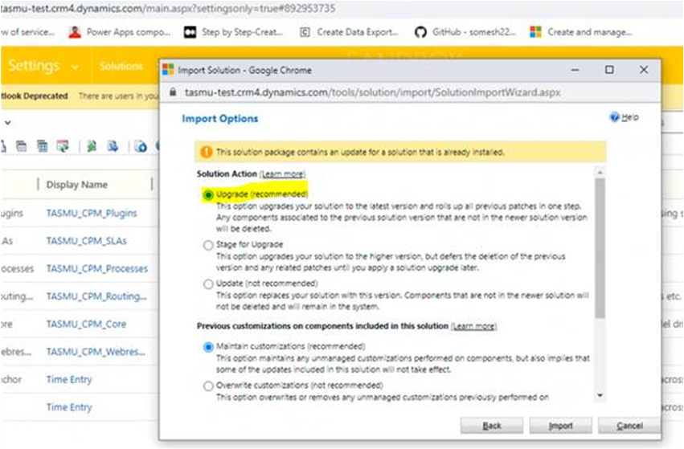  
And unregister below:  
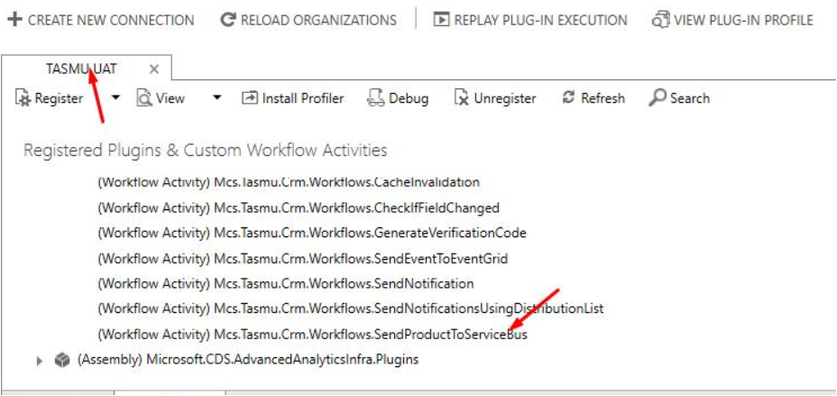

|  |  |
| --- | --- |
| **Build Id** | **Pipeline Name** |
| 32683 | [CD-CrmPlatform-Release](https://dev.azure.com/TASMUCP/TASMU%20Central%20Platform/_build/results?buildId=32683&view=results) |

## Platform APIs

|  |  |
| --- | --- |
| **Tag** | **Pipeline Name** |
| SIT_API_11Mar2021 | [CD-PlatformAPIs-Prd-Release](https://dev.azure.com/TASMUCP/TASMU%20Central%20Platform/_build?definitionId=1021) |

## Bot

|  |  |
| --- | --- |
| **Tag** | **Pipeline Name** |
| SIT_Bot_11Mar2021 | [CD-BotApi-Prd-Release](https://dev.azure.com/TASMUCP/TASMU%20Central%20Platform/_build?definitionId=1022) |

## CDN

|  |  |
| --- | --- |
| **Tag** | **Pipeline Name** |
| SIT_CDN_11Mar2021 | [CD-CDNContainer-Prd-Release](https://dev.azure.com/TASMUCP/TASMU%20Central%20Platform/_build?definitionId=1019) |

## Web Apps

|  |  |
| --- | --- |
| **Tag** | **Pipeline Name** |
| SIT_Web_11Mar2021 | [CD-WebApps-Prd-Release](https://dev.azure.com/TASMUCP/TASMU%20Central%20Platform/_build?definitionId=1020) |

## APIM

|  |  |  |
| --- | --- | --- |
| **Tag** | **APIs** | **Pipeline Name** |
| SIT_APIM_11Mar2021 | cmscontentapi;cmsdocumentsapi;cmsmediaassetsapi | [CI-APIMConfig-CentralPlatformCore-Master-Prd-Build](https://dev.azure.com/TASMUCP/TASMU%20Central%20Platform/_build?definitionId=1150) |
| SIT_APIM_11Mar2021 | cmscontentapi;cmsdocumentsapi;cmsmediaassetsapi | [CD-APIMConfig-pre-Release](https://dev.azure.com/TASMUCP/TASMU%20Central%20Platform/_build?definitionId=962) |

## Mobile

|  |  |  |
| --- | --- | --- |
| **Platform** | **Build Id** | **Pipeline Link** |
| Android | 32971 | <https://dev.azure.com/TASMUCP/TASMU%20Central%20Platform/_build/results?buildId=32971&view=results> |
| iOS | 32972 | <https://dev.azure.com/TASMUCP/TASMU%20Central%20Platform/_build/results?buildId=32972&view=results> |

## B2C Tenant Policy Files

1. Upload new policy files. [Tag - SIT_Web_11Mar2021](https://dev.azure.com/TASMUCP/TASMU%20Central%20Platform/_git/web-apps?version=GTSIT_Web_11Mar2021)
2. File names below:
   1. B2C_1A_B2B_TrustFrameworkBase_<env>.xml
   2. B2C_1A_B2B_TrustFrameworkExtensions_<env>.xml
   3. B2C_1A_BO_TrustFrameworkBase_<env>.xml
   4. B2C_1A_BO_TrustFrameworkExtensions_<env>.xml
   5. B2C_1A_TrustFrameworkBase_<env>.xml
   6. B2C_1A_TrustFrameworkExtensions_<env>.xml
3. Please apply any B2C policy customizations selectively done for pre prod environment. Eg: Disabling email verification check on registration.

# 💻 Reviewers

|  |  |
| --- | --- |
| Prepared By | Manvir Kaur, Sumit Gupta, Sutan Dan |
| Company name | Microsoft |
| Reviewed by | Ravi Sankar Pillutla, Anil Erkek, Abhishek Ghosh, Subhajit Chatterjee, Gareeb Navas T M, Mecit Atmaca |
| Approved by | Ashwani Sharma |

# Appendix

## Running Pipeline from Tags

